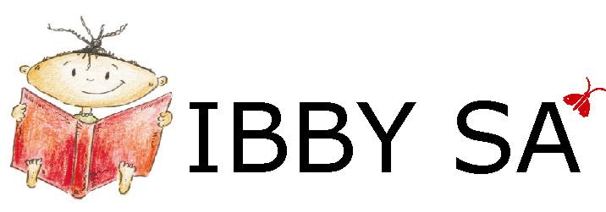
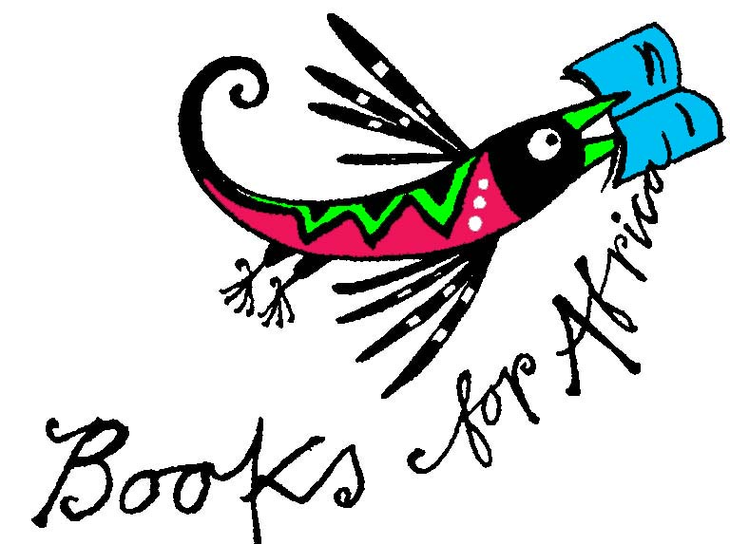
NEWSLETTER No. 60
April 2010

IBBY SA Box 847 Howard Place 7450 South Africa
email info@ibbysa.org.za
Books for Africa newsletter email booksforafrica@iafrica.com
website www.ibbysa.org.za
- IBBY SA is the South African section of IBBY.
- IBBY is the International Board on Books for Young People.
- IBBY SA’s area of interest is everything to do with South African books for children and young people.

- If you are a member of IBBY SA, you are also a member of IBBY.
- IBBY’s 2004 World Congress was hosted by IBBY SA in Cape Town.
- The 2010 World Congress will be in Santiago de Compostela, Spain

Hartlik welkom! Geniet die nuusbrokkies en die artikels wat volg.
O amohelehile! Re tshepa hore o tla thabela ho bala pampitshana ena e fupereng tse thahasellisang le tse susumetsang.

Index: Astrid Lindgren Memorial Award Winner
Hans Christian Andersen Award Shortlist And the winner is … A Blog of interest
Here’s another blog Another sort of list altogether The Kids’ Lit Quiz 2010
KitsKompetisie Summer BookBash Reviews End

Astrid Lindgren Memorial Award Winner
Back to Index

KITTY CROWTHER is an illustrator and author, born in 1970, who lives and works in Belgium. The jury’s citation reads as follows:
Kitty Crowther is the master of line but also of atmosphere. She maintains the tradition of the picture book while transforming and renewing it. In her world, the door between imagination and reality is wide open. She addresses the reader gently and personally, but with profound effect. In her deeply felt empathy with people in difficulty, she shows ways in which weakness can be turned into strength. Humanism and sympathy permeate and unify her artistry.

In Kitty Crowther’s books, text and pictures form an integral whole. Her principal works are her own picture books, including L´enfant racine (2003), La visite de Petite Mort (2004), Le grand désordre (2005) and the Poka & Mine series (2005, 2006, 2007, 2010).

She addresses readers personally using a limited repertoire of tools, principal among them pencil, ink and coloured pencils. Facial expressions, posture and atmosphere are captured with unfailing precision. In Kitty Crowther’s world there are no basic stereotypes. The landscapes in which the stories are set resemble the ones we know, but Kitty Crowther sees beyond them to a world richer in possibilities than we imagine.

One of the cornerstones of her authorship is to show how weakness can be turned into strength. Her loyalty to children is unconditional. The sympathy and intense empathy Kitty Crowther shows with her fictional characters is an expression of the deep humanism that runs through all her works.

Examples of Kitty Crowther’s world of imagery can be downloaded from www.alma.se. For more images and interviews with the Astrid Lindgren Memorial Award winner and jury, please contact the ALMA office: agnes.lidbeck@alma.se or +46 76 540 10 17.

Hans Christian Andersen Award Shortlist
Back to Index
The Hans Christian Andersen Award Jury of the International Board on
Books for Young People (IBBY) announces the 2010 Shortlist

Five authors and five illustrators have been selected from 55 candidates submitted by 32 national sections of IBBY for the 2010 Hans Christian Andersen Award. The award, considered the most prestigious in international children's literature, is given biennially by the International Board on Books for Young People to a living author and illustrator whose complete works have made lasting contributions to children's literature. The winners will be announced on Tuesday, March 23rd at the Bologna Children's Book Fair. The five short-listed authors in alphabetical order are:
- Ahmad Reza Ahmadi from Iran
- David Almond from the United Kingdom
- Bartolomeu Campos de Queiros from Brazil
- Lennart Hellsing from Sweden
- Louis Jensen from Denmark
Ahmad Reza Ahmadi's fascinating short stories speak poetically about humanity, love, nature and peace for children and young adults. David Almond's works are deeply philosophical novels that appeal to children and adults alike, and encourage readers by his use of magic realism. Bartolomeu Campos de Queiros as an author of poetic prose and playful poetry is highly admired for his commitment to beauty and art. Lennart Hellsing is an outstanding poet, who shares the pleasure of language through his mastery of rhythm, word games and invented words. Louis Jensen is a powerful storyteller and entertainer who combines magic and reality.
The five short-listed illustrators in alphabetical order are:
- Jutta Bauer from Germany
- Carll Cneut from Belgium
- Etienne Delessert from Switzerland
- Svjetlan Junakovic from Croatia
- Roger Mello from Brazil

Jutta Bauer creates a harmony between the verbal and visual language, using a philosophical approach in her originality and creativity. Carll Cneut's amazing works powerfully narrate stories in his highly recognizable visual language. As a pioneer of modern picture books, Etienne Delessert's impact on many great illustrators around the world can be recognized. His blending of magic and realism, grotesque and close-ups, has created a distinctive style. Svjetlan Junakovic presents beautiful compositions that are expressive and emotional, while at the same time playful, imaginative and evocative. Roger Mello's world is a rich spectrum of techniques, imagination, colour and inspiration that is considered innovative, fascinating and intriguing.
A full list of candidates can be found at www.ibby.org.
The ten members of the 2010 Jury were led by Jury President Zohreh Ghaeni from Iran. They are: Ernest Bond (USA), Karen Coeman (Mexico), Nadia El Kholy (Egypt), María Jesús Gil (Spain), Jan Hansson (Sweden), Annemie Leysen (Belgium), Darja Mezi-Leskovar (Slovenia), Alicia Salvi (Argentina), Helene Schär (Switzerland) and Regina Zilberman (Brazil). Elda Nogueira from Brazil represented IBBY and Liz Page acted as Jury Secretary.

And the winner is …
Back to Index

Bologna, Italy... The Hans Christian Andersen Award Jury of the International Board on Books for Young People (IBBY) has announced that David Almond, from the United Kingdom, is the winner of the 2010 Hans Christian Andersen Author Award and that Jutta Bauer, from Germany, is the winner of the 2010 Hans Christian Andersen Illustrator Award. The announcement was made at the Bologna International Children's Book Fair, and the Andersen medals and diplomas will be presented to the winners on Saturday, 11 September 2010 at the international IBBY congress in Santiago de Compostela, Spain.
The Hans Christian Andersen Award is considered the most prestigious in international children's literature, is given biennially by IBBY to a living author and illustrator whose complete works are judged to have made lasting contributions to children's literature. Her Majesty Queen Margrethe II of Denmark is the Patron of the Andersen Awards. The Author's Award has been given since 1956 and the Illustrator's Award since 1966. Nami Island Inc. is the sponsor of the Hans Christian Andersen Awards. Information, including a history of the awards is available at www.ibby.org.

A Blog of interest
Back to Index

Gary Hirson writes:

I’m not sure if I mentioned that I started a blog http://blogs.news24.com/selfpublishing about my journey of self publishing. It refers to all the books I read, sites I visited and associations like IBBY which helped me get my books out.

Gary Hirson

www.calminstorm.com
(Books and Talks)

www.garyhirson.com (Photography)

www.blogs.news24.com/selfpublishing

www.goalsettingkidz.wordpress.com

www.ghphotography.wordpress.com

Cell: 083 608 2

Here’s another blog
Back to Index

Maggie Davey of Jacana Books sent us this URL:

Recommended Inappropriate books
http://curiouspages.blogspot.com/

Here’s a review of it:

Looking for books about teddy bears or rainbows or feelings? You’re at the wrong place, says this delightful blog dedicated to wacky, unusual and creepy books for children. Here talking potatoes tell you how

vegetables of the world unite to cry ‘Long live the Revolution!’ and revolt against mean knife-wielding chefs whose chopping and dicing make a Quentin Tarantino movie look like an episode of Barney. And who can resist Uncle Shelby’s ABZ book, which teaches the alphabet, spelling, counting, potty training, ink drinking, scotch tasting, spitting, yelling, egg throwing and fire starting? A wonderful blog to visit and revisit. – Fourie Botha

Another sort of list altogether
Back to Index

It was Beverley Naidoo who gave us the idea. As an event happening parallel to the London Book Fair, on 23 April there is to be a celebration of the 25th anniversary of the publication of her immensely successful book Journey to Joburg. She thought it would be good for IBBY SA to have a ‘presence’ at this event. So she suggested we have something to put on the seats of all the attendees. So I asked Isabel Essery to help me and we compiled a pamphlet called Recent South African Books for Children and Young People 2005 – 2010. Once we had compiled the list, we asked Inge Paulsen if she would design a cover in the same vein as her previous ones for 100 Representative South African Books for Children and Young People and 100 South African Children’s Picture Books.

There wasn’t time for us to print and then post the finished product to get to London in time, and so we emailed the file and Esther Grieder of the Canon Collins Trust very generously looked after printing and collating and folding and stapling.

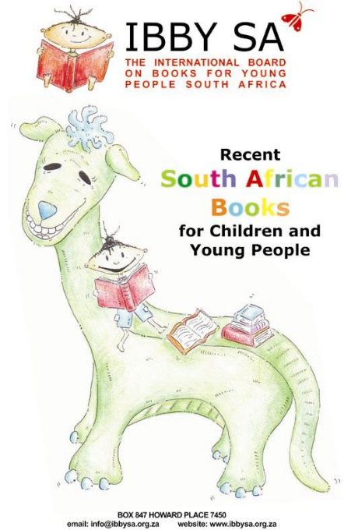We will be doing all of that in time for this year’s (somewhat later-than-usual) Cape Town Book Fair, so that the new pamphlet will be available at the IBBY SA stand at that event. (See the Calendar on p. xx.)

Looking at this list and numbering it, I’ve decided that we may have to stop whining that South African publishers don’t publish South African children’s books. There are 280 titles in the list. If you take into account the fact that more and more of these titles are now being translated into a variety of South African languages, it comes to feel pretty impressive number of books being produced.

What emerges overwhelmingly from a glance through the list is the fact that far more Afrikaans titles are being produced than titles in English or any other South African language. Well done! to the predominantly Afrikaans publishers. Socks up! to the predominantly English publishers. – Robin Malan

The Kids’ Lit Quiz 2010
Back to Index

In the February newsletter you will have read the background information on this very popular reading quiz for children ages 10 to 13 years, the brainchild of Wayne Mills, senior lecturer in the Faculty of Education at the University of Auckland, New Zealand.

The Cape Town heat took place on Monday 8 February in the evening. The large Rustenburg Junior School Hall was filled to capacity as 28 teams took part. This is the largest number of participants in the seven years that South Africa has been taking part in this International Quiz (Quiz has been going since 1991) and the competition was fierce.

The only way to prepare for this quiz is to read as widely as possible, stay up to date with the young-adult literary award-winners and read across as many genres as possible. The children have no idea what questions they will be asked.

Wayne Mills, the Wizard of Words, was in sparkling from, dressed in black and sporting his large velvet hat with the word ‘Quizmaster’ embroidered on it. He interacted with the teams, cheering them on and applauding the winners after each round. He handed out prizes of R200 in vouchers, donated by the sponsors Exclusive Books, to the winners of each of the ten categories.

For added incentive, Wayne had a pocket full of R5 coins, which he awarded to the winners of the spot questions that he asked throughout the evening.

There were ten categories with ten questions in each. This year the categories were: Cats, Comic Titles, Creatures, Families, Lit Knowledge, Little People, Music, Odd One Out, Pop Culture, and Secrets.

The questions in each category were wide-ranging, covering all aspects of literature from myths to children’s classics, contemporary fiction to nursery rhymes. There is a huge emphasis on visual literacy in New Zealand, so graphic novels and comics also featured. The excitement and tensions were palpable and when Wayne read out the answers there were groans of disappointment or happy smiles and high fives.
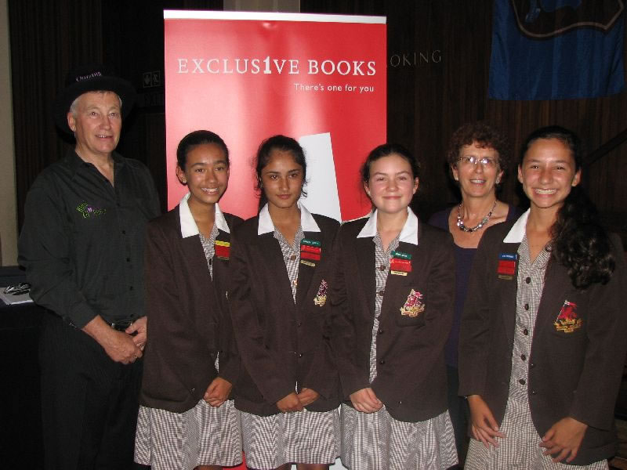
Wynberg Girls’ Junior School were the final winners of the evening with an excellent score of 83.5 points out of a possible 100; 2nd came Grove Primary with 79; and 3rd were Bay Primary with 76.5. The overall winners received cash and book prizes.
The Wynberg team travelled to the South African finals, which took place this year in Pietermaritzburg. Exclusive’s put on a nice lunch and supplied lots of books, so no individual went away with fewer than eight books. The winning team was The Ridge from Johannesburg. The Final results were as follows: The Ridge 38, Athlone 24, Wynberg 23, St Henry’s Marist 21, Harvest Christian 18, Waterkloof House 14, Parkview Senior 11, Epworth 10.

The Ridge team will now travel to Edinburgh in August to represent South Africa in the World Final. We wish them the very best of luck. – Kathy Madlener

Wayne Mills with the winners of the Cape Town heat…Wynberg Junior and their librarian Mrs Baerecke

QuickCompetition KitsKompetisie
Back to Index

Veels geluk aan Coenraad Walters, Somerset College, die wenner van ons kompetisievraag. Die korrekte antwoord was ‘die donker man’ uit die gedig ‘Toemaar, die donker man’ wat in Ingrid Jonker se bundel Rook en Oker in 1963 verskyn het.

Here’s the new question:
Spud by John van de Ruit has been made into a movie. A well-known South African

actor who played the part of Shylock in The Merchant of Venice last year at Maynardville will be playing the part of The Glock. Name the Actor.

Send in your answer quick-sticks to booksforafrica@iafrica.com – and remember to give your postal address in case you win.

Summer BookBash
Back to Index

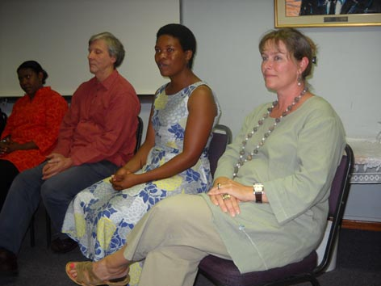

What’s the phrase? ‘A small but discriminating audience’ attended the Summer BookBash. And it was a very good session. There was a good strong group of people to keep the evening moving along happily: Bronwyn de Klerk, Nadeema Musthan, Norman Skillen, Lisa Cohen, Gillian Southwood, Rupal Ganatra and Xolisa Guzula. First, there was a panel discussion, where, with Nombulelo Baba as Chair, the group addressed the question: ‘Is story-telling still relevant?’ The trouble with this kind of discussion is that, once you’ve established that everyone in the room agrees that story-telling is still relevant, where do you go from there? The main avenue, it was easily settled upon, was to get teachers in schools not only aware of the various benefits and educative values of story-telling, but also trained in the practice of telling – as well as reading – stories to their students. People are doing this in small individual areas, and a group such as the one before us accepted that they, too, had a responsibility to go out and propagate the idea and teach the teachers. IBBY SA is very ready to be of whatever facilitating assistance it can be. One other concern was later raised by George Ellis, part of the audience, and that was the fact that we had not discussed what kind of stories we should be telling.

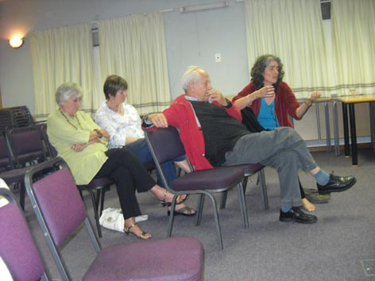

Stuart and Warren of ‘Share a Story’ were there to tell us of their enterprise in launching www.shareastory.net , to build a stock of stories by inviting you to tell yours online. (Keep checking on the site: it’s not quite ready right at the moment, but go and have a look at it.)

Then, the second part of the evening: the story-telling itself. Each member of the group told a story, in her or his own individual way.

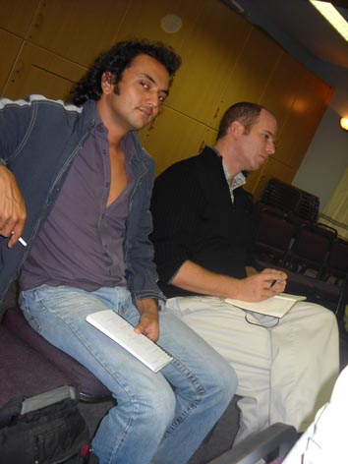

Very easy to see how a group or class of students could find themselves engrossed in the world of the story.

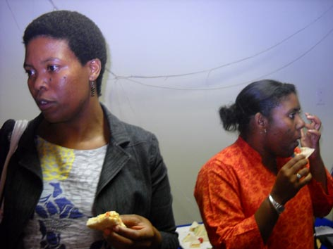

Warm thanks to the entire group for giving us their time and expertise in this way. And thanks to Nombulelo and Xolisa for putting it all together. – Robin Malan

Reviews / Resensies
Back to Index

For full reviews of the following books, please go to our website:
Vir die volle resensies van die volgende boeke, gaan asb. na ons webwerf: www.ibbysa.org.za

Drie hoera’s vir Denver! deur Wendy Maartens met illustrasies deur Alida Bothma (LAPA, 2009) – Lona Gericke

Prinses Mossienes deur Wendy Maartens, met illustrasies deur Alida Bothma (LAPA, 2009) – Lona Gericke

Sussie Veer is dood en ander verhale, saamgestel deur Riana Scheepers en Rachelle Greeff (Maskew Miller Longman, Kaapstad, 2009) – Lona Gericke

End
Back to Index
Text: Robin Malan, Kathy Madlener, Fourie Botha
Layout & Design: Inge Paulsen

