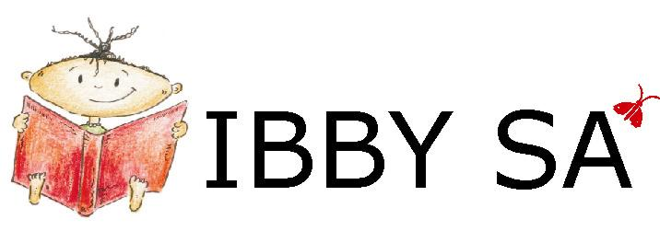
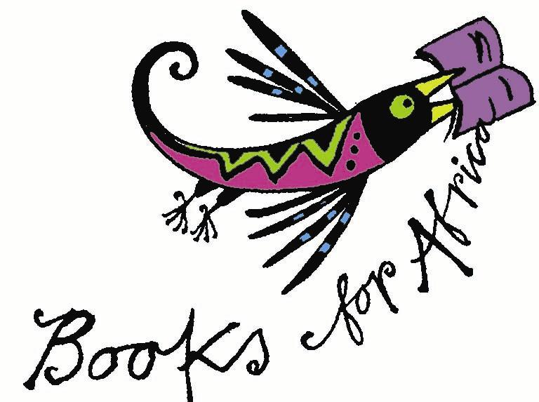

NEWSLETTER No. 42

April 2007

IBBY SA Box 847 Howard Place 7450 South Africa
email info@ibbysa.org.za
Books for Africa newsletter email booksforafrica@iafrica.com
website www.ibbysa.org.za
- IBBY SA is the South African section of IBBY.
- IBBY is the International Board on Books for Young People.
- IBBY SA’s area of interest is everything to do with South African books for children and young people.

- If you are a member of IBBY SA, you are also a member of IBBY.
- IBBY’s 2004 World Congress was hosted by IBBY SA in Cape Town.
- Its next World Congress will be in Copenhagen, Denmark, in 2008

O amohelehile! Re tshepa hore o tla thabela ho bala pampitshana ena e fupereng tse thahasellisang le tse susumetsang.

Index:
The Big Announcement Additions to IBBY SA Exec 100 Books List @ CTBF
Specialist Children’s Bookshops VinnigVra Kompetisie STORIEWERF
Astrid Lindgren Award Reviews End

The Big Announcement!
Back to Index
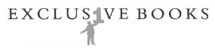

We are really pleased and proud to announce the inauguration of

The Exclusive Books IBBY SA Prize

This will be awarded every second year to the best original picture book or illustrated children’s book by a South African writer and illustrator. The prize will be shared equally by the writer and illustrator. It will not matter in which South African language the book is written. The prize is open to any and all published books and all publishers in South Africa.
The sponsor of the prize is Exclusive Books. The prize money is R5 000 for the writer and R5 000 for the illustrator. If one person is both writer and illustrator, that person is awarded the prize of R10 000. If there are two or more authors or two or more illustrators, the respective prize is shared equally.
The prize will be presented to the winning author and illustrator at an event sponsored and arranged by Exclusive Books. The judging of the prize will be entirely in the hands of IBBY SA.
The first award will take place in 2007. Books published from 1 January 2006 to 30 June 2007 are eligible. The closing date for submission is 30 June 2007. The Award will be announced at an event in September 2007.
The next award will be in 2009, and books published from 1 July 2007 to 30 June 2009 will be eligible; and so on into the future. Should the number of entries warrant it, the sponsors will consider making the award an annual event.
The Exclusive Books representative in charge of the administration of the award is Penny Hochfeld, while IBBY SA is represented by Lona Gericke and Veronica Behm. The IBBY SA Jury will have on it a publisher of children’s books, a Fine Arts academic in the field of design and illustration, book selectors, librarians and university lecturers in librarianship and inform-ation science.
IBBY SA is deeply grateful to Exclusive Books and its Managing Director Fred Withers for this commitment to South African children’s books, and we look forward to a long and happy association in this prestigious venture. We feel confident that all of our children’s writers, illustrators and publishers will embrace this acknow-ledgement of their talents and skills.
Exclusive Books will put out a call to all authors, illustrators and publishers to submit entries for the 2007 prize between now and 30 June 2007.
To obtain a copy of the Rules of the Exclusive Books IBBY SA Prize, please email any of the following:
pennyh@exclusivebooks.co.za
Lona.Gericke@capetown.gov.za
Veronica.Behm@capetown.gov.za
booksforafrica@iafrica.com
The rules will be placed on the IBBY SA website within a week or so: go to www.ibbysa.org.za

Additions to the IBBY SA Exec
Back to Index
We are happy to announce the following additions to the IBBY SA Exec:
Ons is bly om die volgende nuwe lede van die IBBY SA UK aan te kondig:

- Isabel Essery of New Africa Books
- Fourie Botha of Nasou Via Afrika
- Jean Williams as the representative of Biblionef SA
- Nonikiwe Mashologu as the representative of the Centre for the Book
- Rozelle van Schaik as Treasurer and Accountant

As you see, we have strengthened our links and ties with our close partners Biblionef SA and the Centre for the Book by inviting them each to have a representative on the Exec. We welcome all the new members, and look forward to their valuable contributions. Hartlik welkom aan al die nuwe lede! Namkelekile!

We hope soon to announce a strengthening of the Exec in the north, specifically in Gauteng.

The 100 Books List at the Cape Town Book Fair
Back to Index


The updating of the IBBY SA 100 Representative South African Books for Children and Young People 2007 is now very nearly complete.
We are happy to announce that this list will be unveiled and the exhibition of the books displayed at the IBBY SA Stand at the Cape Town Book Fair (CTBF), which takes place 16–19 June 2007.
Watch out for all the details of our stand in the June Books for Africa newsletter, which will be sent out early in June.
In addition, the 100 Books Display Exhibition will form IBBY SA’s participation in the Nami Island Children’s Book Festival in Korea from 1 May to 1 July 2007, and will then be exhibited in the South African Embassy in Seoul. This has been achieved through a collaboration between IBBY SA and the Children’s Literature Research Unit at UNISA.
Our warm thanks to all the publishers for so willingly and readily supplying copies of the books for these exhibitions. They can be assured of the influence that the exhibition will exert on libraries, schools and the public, both here and abroad.
After the CTBF, the physical exhibition of the 100 Books will be housed at Biblionef SA in Pinelands, Cape Town. In due course, the 100 Books List will become a virtual exhibition on the IBBY SA website: www.ibbysa.org.za .

Specialist Children’s Bookshops
Back to Index
There are three such bookshops in Cape Town, and this month we review them. Please send us a review of any others that you know about, elsewhere in the country – email your review to booksforafrica@iafrica.com .

KEiDA Children’s Books

Shop G4 Richmond Centre 146 Main Road Plumstead Cape Town

Tel 797 7117 email sales@keida.co.za

This small but personal children’s bookshop, situated next to the ABSA Bank in Plumstead with lots of free parking, has been operating for about nine months. The owner Kitten Matthews was away when I visited and the shop was manned by her very helpful and knowledgeable assistant. She told me they personally select all their stock and read it too so that they can advise their clients.

First impressions are of a rather uninspiring space, beige carpets, yellow walls, a few beanbags and some plastic children’s chairs. Four free-standing bookshelves, one for each age group from age 0 up to teens, contain a small but well-chosen selection of South African and overseas fiction titles. Almost all the books are shelved with the covers facing outwards which is most inviting.

When I remarked that they were carrying rather a small stock, the manageress hastened to explain that a huge order had left a couple of days earlier for a school in Jo’burg and they were waiting for their new

stock to arrive. She said they had had to spread out their stock, in fact, to fill up all the gaps so maybe the books don’t always face cover-out!

A large wall unit houses non-fiction and titles in other languages, especially those spoken in SA. I found the SA stock up-to-date and well-chosen. Most of the leading SA children’s authors are represented. SA authors are regularly invited to give readings of their books. Niki Daly read to a packed shop, Janet Keegans read from her collection of short tales Kubuka and the Magic Kalabash (Struik, 2004), and Wendy Hartman has agreed to talk in the future. All clients are added to the mailing list and receive invitations and other news. Discounts of between 10 and 15 % are given to schools.

I left the shop impressed with the passion and commitment to children’s literature, especially South African, and I plan to return soon.
– Kathy Madlener

Back to Index
a is for apple – the children’s book store
16B Kloofnek Road Tamboerskloof Cape Town
Tel 021 424 5409

General Comments:
Is the shop child friendly? Are there comfortable places for children to sit and browse?
Aesthetically A is for Apple is beautiful. It has lots of space for children to browse, and to engage with the books. There is also a coffee shop where adults can look at the books while their children are in the shop.
What is the stock like generally?
A is for Apple has an impressive stock of mainstream current children’s books, as well as classics like the Eloise books, The Railway Children, CS Lewis, etc. South African titles are a bit thin on the ground, unfortunately. and South African books for young adults are barely represented as far as I could see.
What is the customer service like? Is the staff well informed?
Both the booksellers behind the desk were friendly and well informed. They are obviously well liked and well known by their customers and people felt free to ask them any number of questions.

How well are South African books for children represented?
Indigenous languages
There did not seem to be many indigenous languages represented.

There were a few multilingual texts, and the Afrikaans versions of the Harry Potter books were available.
Picture books
It appeared that there was one shelf dedicated to South African children’s books. They were not prominently displayed. Niki Daly’s books were well represented, but there did not seem to be a large selection of local picture books available.
Chapter books for younger children.
I did not find anything displayed; however, I may have missed these.
Books for teenagers
As I mentioned, the Harry Potter books were available, as were a few of the other Human & Rousseau titles.
How are these categories presented:
At the front of the shop, prominently displayed or tucked away out of sight?
The picture books were on a separate shelf, for the most part spine out rather than face out. There was a pile next to the till of the new book UTshepo mde / Tall Enough by Mhlobo Jadezweni and Hannah Morris, which was good to see.
Are there posters advertising local series, authors, readings, etc.?
I did not see any posters advertising local authors and readings, although there was a local children’s magazine for sale.
– Isabel Essery

DEB’S
Silwood Centre, Campground Road, Rondebosch

General Comments:
Is the shop child-friendly? Are there comfortable places for children to sit and browse?
The shop stocks toys, puzzles, games and books. The books are in one section, but share the space with other things. There is no space to sit and browse – the shop is more functional.
What is the stock like generally?
There is not much variety in the stock, and there is nothing that immediately grabs the attention as being different or special. However, South African titles seemed to be better represented here than in A is for Apple.

How well are South African books for children represented?
Indigenous languages
There were not a lot of indigenous languages on display.
Picture books
There was a good selection of South African picture books on display, most of which were on the shelves face out.
How are these categories presented?
The South African and international titles were displayed together.
– Isabel Essery

Back to Index

VinnigVra Kompetisie QuickQuiz Competition

There was only one entry for the last competition, and that one was 100% correct!

Die oplossing van die anagramme is:
Mia se ma (I am a mes)
The Hidden Star (Dash the Tinder)
Vaselinetjie (Jane is v. elite)

‘Geluk!’ aan Jaco Jacobs. A copy of The Hidden Star is in the post to you.

This month’s competition:
Where does the Nami Island International Children’s Book Festival take place? Before the smarty-pantses of the world put me on the spot, I’d better rephrase that: Where is Nami Island?
Send your answer by email to booksforafrica@iafrica.com before 15 May and win a trip to Nami Island for the Festival. Kidding. We’ll send you a book, instead.

STORIEWERF
Back to Index


Neem deel aan Storiewerf, die web-tuiste vir kinder- en jeugboeke, se jaarlikse skryfkompetisie. Vanjaar is die tema Kreatiewe Kreature met illustrasies van Josh en Ian Marley as skryfprikkels. Skrywers moet hierdie illustrasies as vonk gebruik om 'n eie storie mee te skryf. Die kompetisie het vyf afdelings: 7-9 jaar, 10-13 jaar, 14-18 jaar, volwassenes, asook 'n af-deling waar 'n ouer/volwassene en kind/ers saam 'n storie mag skryf.

Meer as R8 000 se pryse kan gewen word. Pryse sluit in 'n naweek vir vier by 'n ATKV-vakansieoord, versame-laarsboeke, Storiemanreekse, Afri-kaanse speltoetsers, boeke en boek-bewyse. Die algehele prys is die bywoning van 'n skryfkursus van die ATKV-Skryfskool (Herfsskool 2008). Kompetisieborge is die ATKV, ATKV-Skryfskool, LAPA-Uitgewers, Storie-man, CTexT (NWU), Storiewerf en Kalahari.net.
Die sluitingsdatum vir inskrywings is 15 Mei 2007.

Volledige besonderhede op Storiewerf (http://www.storiewerf.co.za/jongklomp/vonkelfiksie.htm)
Vir navrae kontak Franci Greyling by: franci@storiewerf.co.za of 018 299-1781.
www.storiewerf.co.za
Storiewerf is die inisiatief van Franci Greyling, 'n jeugboekskrywer, en word aangebied in samewerking met skrywers, uitgewers en belang-stellendes in kinder- en jeugliteratuur.
franci@storiewerf.co.za
www.storiewerf.co.za

Isn’t the book world wonderful?
Back to Index
Found on the website of the Bologna Children’s Book Fair 24–27 April 2007:

“ Admission to the Bologna Children's Book Fair is strictly reserved ... Strictly NO children or under-18s. ”

I know it’s a trade fair, but still … it sounds so bizarre!

Astrid Lindgren Award
Back to Index
Unfortunately, it didn’t go to our South African nominees, First Words in Print or Biblionef SA. Instead, congratulations to …

BANCO DEL LIBRO – AWARD WINNER 2007
The Astrid Lindgren Memorial Award 2007 goes to the Venezuelan institution Banco del Libro.
The jury’s motivation is as follows:
’In a true pioneering spirit, with ingenuity and a sheer determination, the Banco del Libro has constantly sought new ways of disseminating books and promoting reading among children in Venezuela. Enthusiasm, professionalism, closeness to the children and a refreshing lack of bureaucracy are the hallmarks of the Banco del Libro’s work, whether in shanty towns, mountain villages, universities or out in cyberspace.’
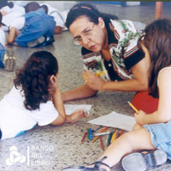

Read more by going to http://www.alma.se/page.php?pid=3214

IBBY SA Member honoured by English Academy

Elwyn Jenkins, Professor Extraordinarius in the Department of English Studies at Unisa, has been awarded the Gold Medal of the English Academy of Southern Africa. The medal, for conspicuous service to English, recognises his contribution as writer, editor, educationist and leader of organisations serving the English language and education. He also holds the Carl Lohann Award of the South African Institute of Librarianship and Information Science. The medal will be presented to him at a function in Johannesburg in June.

Congratulations, Elwyn!

BookBash

Publishers ’n’ Pizza was the first BookBash informal get-together of the year, held at Huis der Nederlanden on Thursday 15 March 2007. Four publishers introduced us to some of their new and recent books. The publishers were New Africa Books, Electric Book Works, Umuzi, and Jacana Media.
The New Africa Books presentation included an update on the newest titles in the Siyagruva Series of novels for South African teens; the new NAB-PRAESA collaboration on an African Pinnochio with the illustrator Elzette Prins; and PRAESA’s Little Hands series of stories for the whole of Africa, introduced by Carole Bloch.
Jacana Media talked about their series on South Africa’s national days; the series of source-books on the provinces; and two new picture books, Three Friends and a Taxi and The Cool Nguni, both written by Maryanne Bester and illustrated by Shayle Bester.
Electric Books Works introduced us to their bilingual book UTshepo mde / Tall enough by Mhlobo Jadezweni, while the illustrator Hannah Morris gave us an insight into the particular interests and challenges of interpreting the story visually.
Umuzi, a division of Random House South Africa, posthumously published The Hidden Star by K Sello Duiker, a magical book for young people. The actor Marty Kintu read from the book.
There was lively discussion around some of the issues raised by the books, and members enjoyed looking at the books and chatting to the publishers over pizzas, kindly provided by the publishers. A good evening, all round.

Stories Across Africa

Stories Across Africa (StAAf), in collaboration with a local publisher from each of Southern, West, Central, East and North Africa, is publishing three anthologies of writing for children: Early Childhood (0-8), Middle Childhood (9-12) and Teenagers (13+). They invite you to submit stories and poems in any African language (with a summary or translation in English, French or Portuguese) or any of the AU official languages. For more info, contact Carole Bloch email: carole.bloch@uct.ac.za

Reviews
Back to Index
READ THE FULL REVIEWS AT: www.ibbysa.org.za

Dolfynedag deur Wendy Hartmann, vertaal deur Simone Hough, met illustrasies deur Robert Foote (Human & Rousseau, 2007) - Lona Gericke

Eighth Man, The by Michael Williams: (Oxford University Press Southern Africa, Cape Town, 2002, 2006) – Robin Malan

Hidden Star, The by K Sello Duiker, with cover designed by Niki Daly (Umuzi, Cape Town, 2006) – Robin Malan

Is daar plek op jou besem? deur Julia Donaldson (Human & Rousseau, 2002; tweede druk 2006) – Lona Gericke

Loergaatjie-reeks, Die: Bome, Plante, Water, en Voëls deur Penelope Arden, vertaal deur Daniel Hugo (Human & Rousseau, 2007) – Lona Gericke

Net vir ouens deur Tiaan Wessels (LAPA, 2006) – Lona Gericke

Saartjie se nuwe maat deur Betti Naude (Human & Rousseau, 2007)
Saartjie se slim plan deur Bettie Naude (Human & Rousseau, 2007) – Lona Gericke

Ster met strepe, ’n deur Wendy Maartens, met illustrasies deur Anna-Carien Goosen (LAPA, 2006), ook in Engels beskikbaar as A star with stripes. – Lona Gericke

SuperZero by Darrel Bristow-Bovey (Tafelberg, Cape Town, 2006) – Robin Malan

Tintin (in Afrikaans Kuifie) (Human & Rousseau, 2006): Bestemming maan, In die land van die swart goud, Verkenners op die maan. – Lona Gericke

Totsiens Tommasino, ’n verwerking van Philip de Vos se Trazom wat in 1992 gepubliseer is (Human & Rousseau, 2007) – Lona Gericke

Trompie die dromer deur Topsy Smith (Human & Rousseau, 2007)
Trompie die speurder deur Topsy Smith (Human & Rousseau, 2007) – Lona Gericke

UTshepo mde / Tall Enough by Mhlobo Jadezweni, illustrated by Hannah Morris (Vuvu Books, Electric Book Works, Cape Town, 2007) – Robin Malan

End
Back to Index

