Children in Crisis Program
Earthquakes in Mexico/September 2017

In December 2017, after receiving the resource of Children in Crisis that IBBY generously sent us to support the Mexican children and teenagers to rebuild their confidence and cope with their losses, IBBY Mexico started to make alliances with other institutions or partnerships to find the way to help where there was an extreme need of shelter and comfort, and to make our work more efficient.
Therefore we established a work plan with the Ministry of Culture in the states of Oaxaca (Espinal and Juchitán) and Morelos in order to work with teachers, whose schools were damaged, providing them the tools to support the children and teenagers through stories.
In five towns of Morelos we made an alliance with “ La Jugarreta”, an association we have worked with on several projects and which is dedicated to the promotion of reading in that state. Together with this association, we were able to complement the work started by UNICEF in five of the “Friendly spaces” they had established.
Before beginning our work in different communities, thirty mediators took a workshop given by ……… a specialist in psychological containment from the Universidad Autónoma de México (Autonomous University of Mexico). We had a workshop called “Metaphors, doors and windows" given by the Ministry of Culture.
More recently IBBY Mexico has started to organize a Bunko in San Gregorio, Xochimilco.
Below are the reports of each place

OAXACA

IBBY Mexico – Ministry of Culture

El “Espinal” and “Juchitán”, Oaxaca
Workshops on "Metaphors, doors and windows", coordinated by IBBY Mexico together with the Ministry of Culture of Mexico, and the Ministry of Culture of the State of Oaxaca. Report of the Section of "Intervention in crisis".
The reading promoter and the people in his reading circle generate a space not only for listening, but also for meeting and exchanging ideas, feelings and situations. Literature provides people with the possibility of identifying themselves in their experiences.

Workshops Objectives
- Provide participants with a series of tools that allow them to strengthen, among other benefits, reading and breathing that contribute to the recovery of the level of functioning and well-being of the people and communities affected by the earthquake of September 7, 2018, in the state of Oaxaca.
- Generate meaningful experiences through Literature, as well as solidarity support, which facilitate a situation of constructive change in the context of the communities.
During the workshop
- “Colibri”, a story edited by the Reencounter Therapy Foundation, was read by the mediator and, at the same time, the participants worked with clay while listening to the story. Individually, they identified the part of the story that was or seemed closer to the experience they had been through.
- An ample variety of books with different was also offered, with which the participants identified themselves. They then formed teams and shared a chosen story. In every team, they identified the episode, character, and values that, together with the episode already identified from the collective reading of "Colibrí", allowed the participants to create their own story.
  - A collective sharing was carried out, in which each team read its story. Final comments were made for the closing.
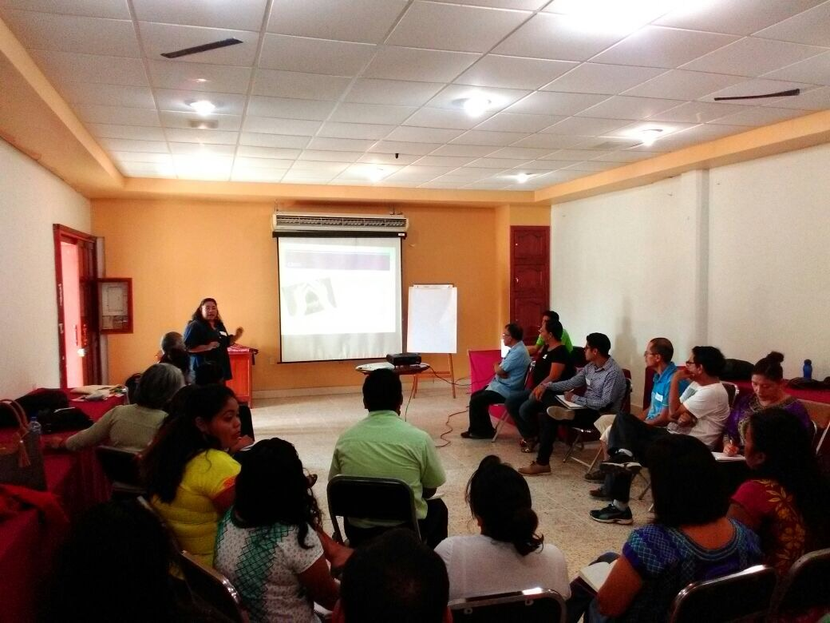
“Juchitán”, Oaxaca
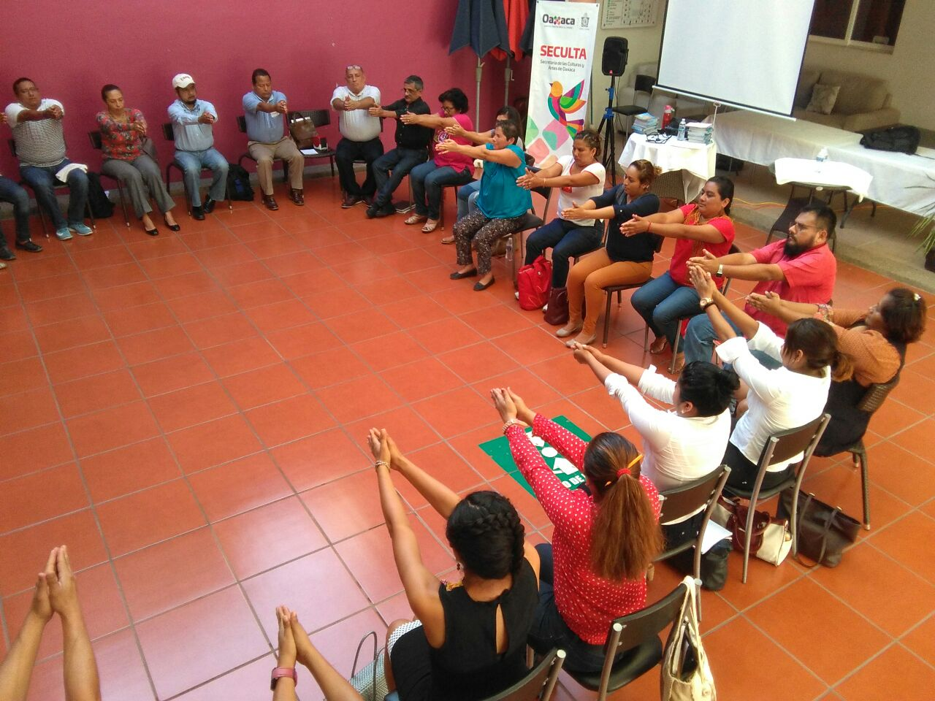
“El Espinal”, Oaxaca
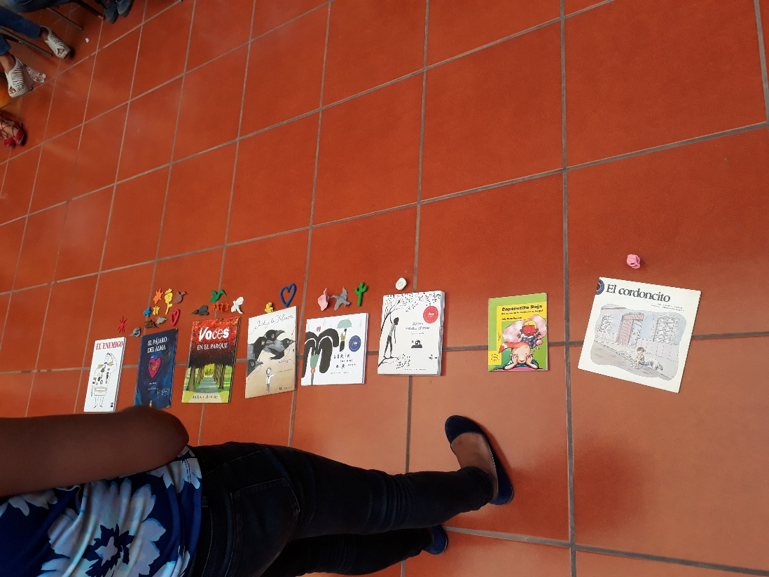
“El Espinal”, Oaxaca

REPORT OF ACTIVITIES OF GROUPS WITH READING CIRCLES
MORELOS
IBBY Mexico – Ministry of Culture
IBBY Mexico and the Ministry of Culture worked together strengthening mediators in a necessary issue in disaster situations: “Intervention in Crisis” 25 reading promoters attended a workshop imparted by the Psychologist Maribel Cuevas, from IBBY Mexico, and consisted in providing basic tools of emotional containment through reading and books. The participants were able to overcome the traumatic experience, and thus to be to contribute in their communities.
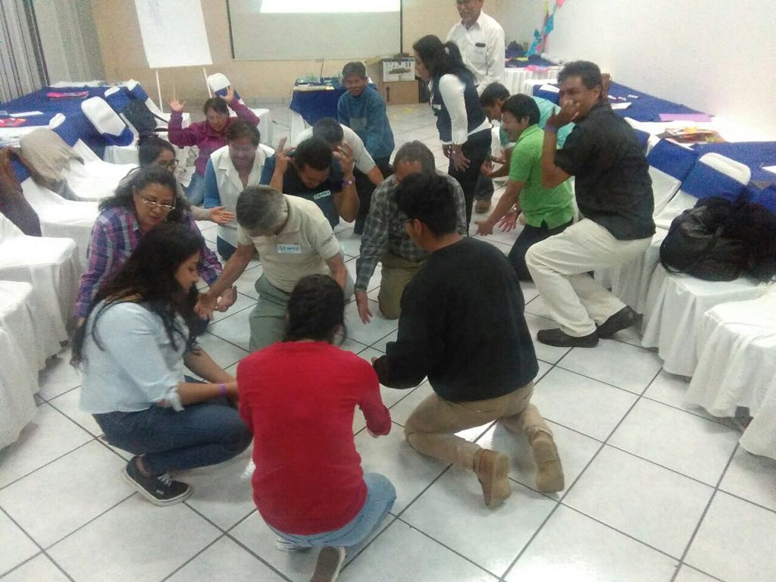
IBBY Mexico – La Jugarreta
Locations

- Hueyapan – Main Square (Plaza principal)
- Tetela del Volcán – “Roofing” of San Miguel neighborhood (Techumbre del Barrio de San Miguel)
- Ocuítuco – San Miguel Huepalcalco, Jumiltepec and Ocoxaltepec communities (Comunidades de San Miguel Huepalcalco, Jumiltepec y Ocoxaltepec)
- Cuautla – Tetelcingo´s Multilingual school (Multilingüe de Tetelcingo)
- Jojutla – Centre (Centro).

Sociocultural context:
After the 19S earthquake and as part of UNICEF's Friendly Children's Space program, the “Altos de Morelos” groups began providing support to children and adolescents. The objectives of this attention are:
• Find allies that through play, recreational and reading activities, serve as psycho-social support.
• Identification, prevention and channeling of cases of violence, child labor exploitation and sexual abuse.
• Provide information to dads, mothers and caregivers on how to protect children and adolescents in emergency situations.
In the spaces of the “Altos de Morelos”, many of these children belong to extended families, cared for by grandmothers or grandparents or a close relative, since their parents go out to work in the fields. There are also children who come from single-parent families with mothers who are heads of families. Most of them attend school and have low economic resources.
In the area of ​​Jojutla, the children attend school intermittently, since the reconstruction of the educational infrastructure continues. The majority of these children are from the so-called "zero zone" of the center of the municipality. Their ages are from 3 to 15 years and the sessions are given in the street and sometimes in the atrium of a chapel. They have a high level of emotional vulnerability which allows great participation in reading circles and the need to spend more time with the group.
Population served:
The population that goes to the spaces is very varied: children and young people from 2 to 17 years old. The reading circles have benefited the youngest children since they are delighted with the books, because they can read from their perception.
They are also taking the activities to the Agricultural technology Center School of “Tetela del Volcán” where there are teenagers who never in their lives had interacted with a book like Go away, Green Monster (Fuera de aquí monstruo verde), for example.
The adolescents enjoy and participate actively; we are in talks to place a stand with the literary collection so that the attendance and participation is free.
Total of Children and young adults attended per week: 300 considering the 5 spaces.
As well, thanks to the Children’s in crisis fund, we received five packages of 50 book each, which were delivered to the five friendly spaces in the different towns mentioned above.
20 mediators were trained to make each space “alive” , and let children enjoy books and reading.
Testimonials:

Girls and boys
"I like books because we can show them to our dads, moms and grandparents. We can read them together. "
"I'm going to read the Green Monster, I like to read it because it has masks."
"We can read and share books ... I do like them."
"I forget about other things and I concentrate more on this ... then I do not even hear if it's dinner time or not ... and I grab a book and go to bed."

Mediators
"The books have complemented the friendly space which we have conditioned with mats. Now books are exchanged; they can be taken to their homes. They children even go to bed to read and see the books. The youngest who still cannot read, are the most excited because they review the books with more images and they tell us in their own way. Together with them we read and explain the readings. Thank you very much."
"We are very excited to know that we already have a collection of books and the most important thing was to see how the children approach and each one takes one to revise or read it. Some of them take them to their homes and this Friendly space makes the loan with receipts and so they and they return it to us and they can take another book. We are very excited. Thank you. Thank you."

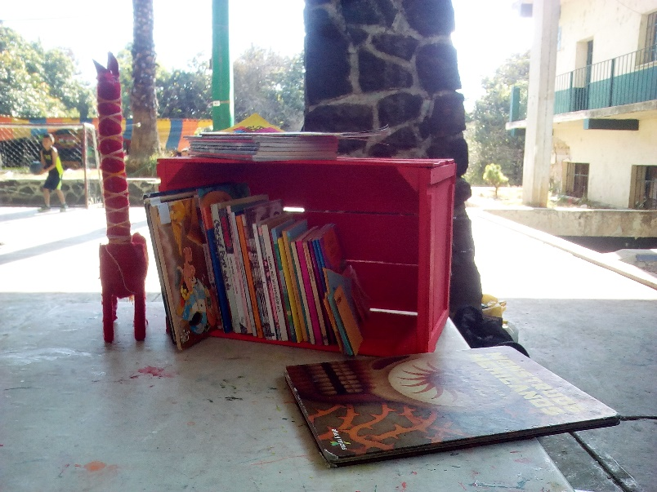
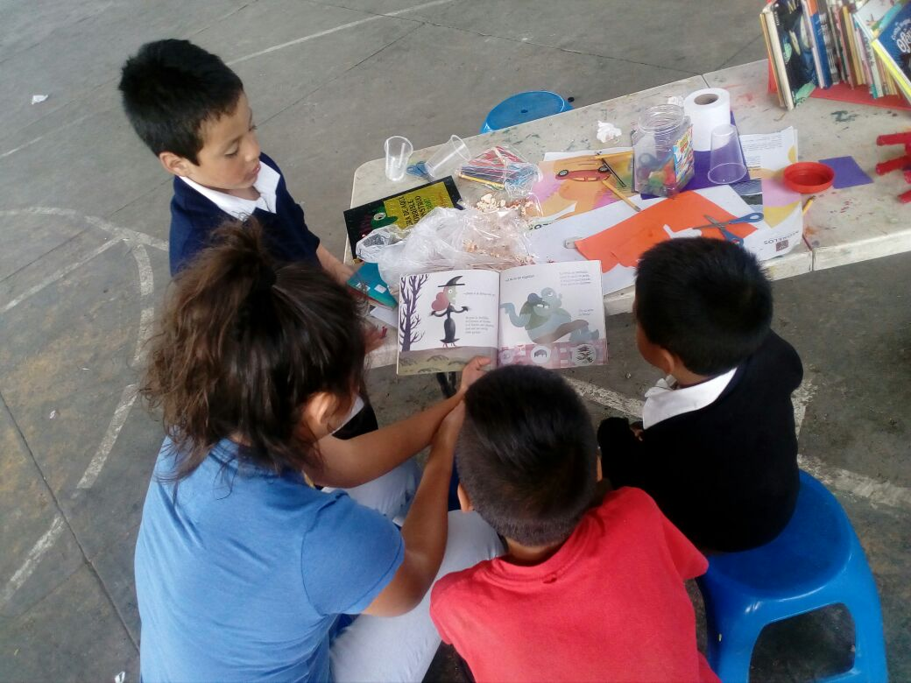
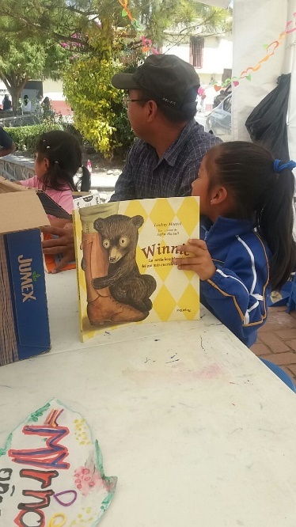
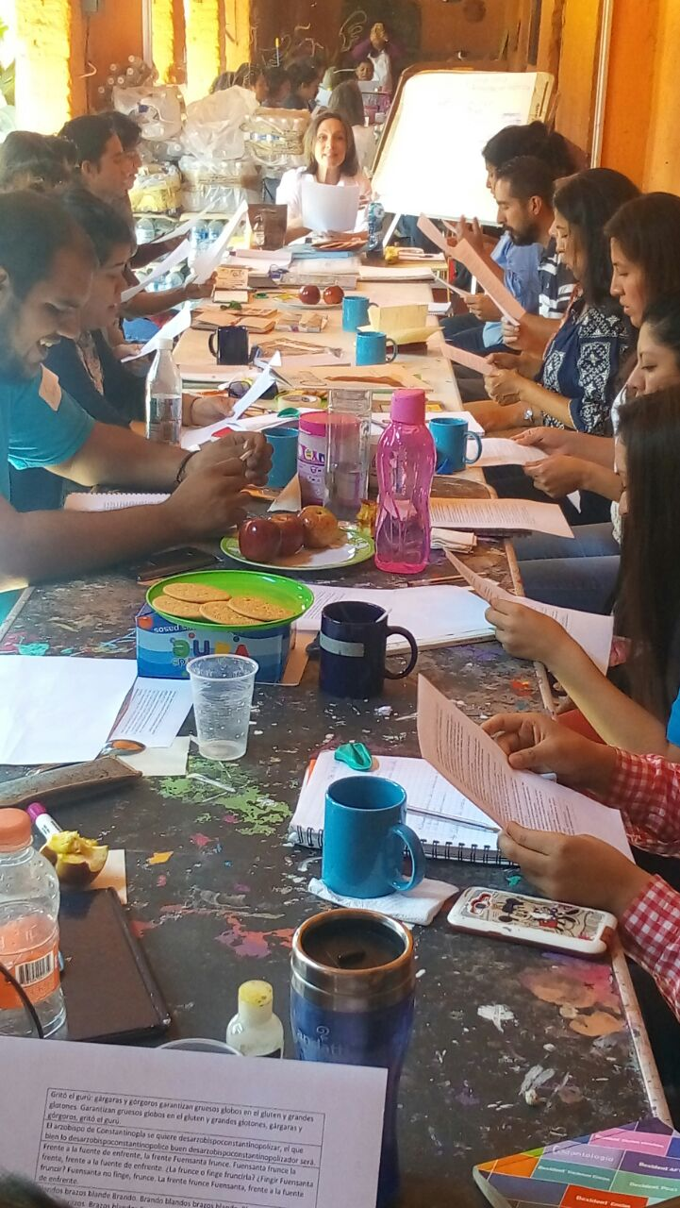

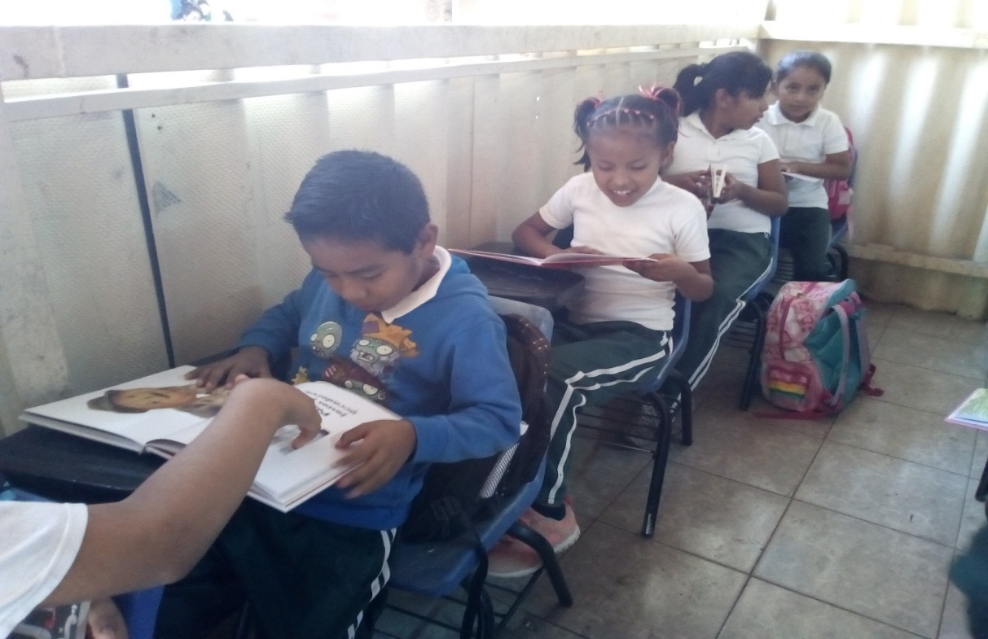

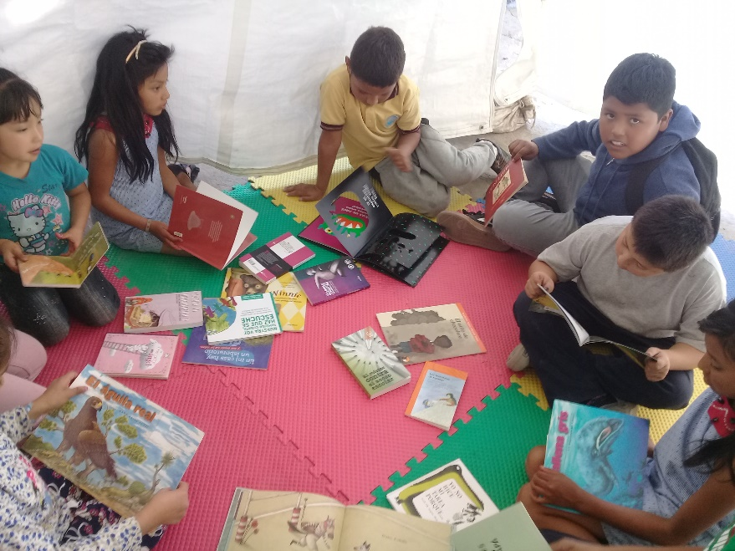

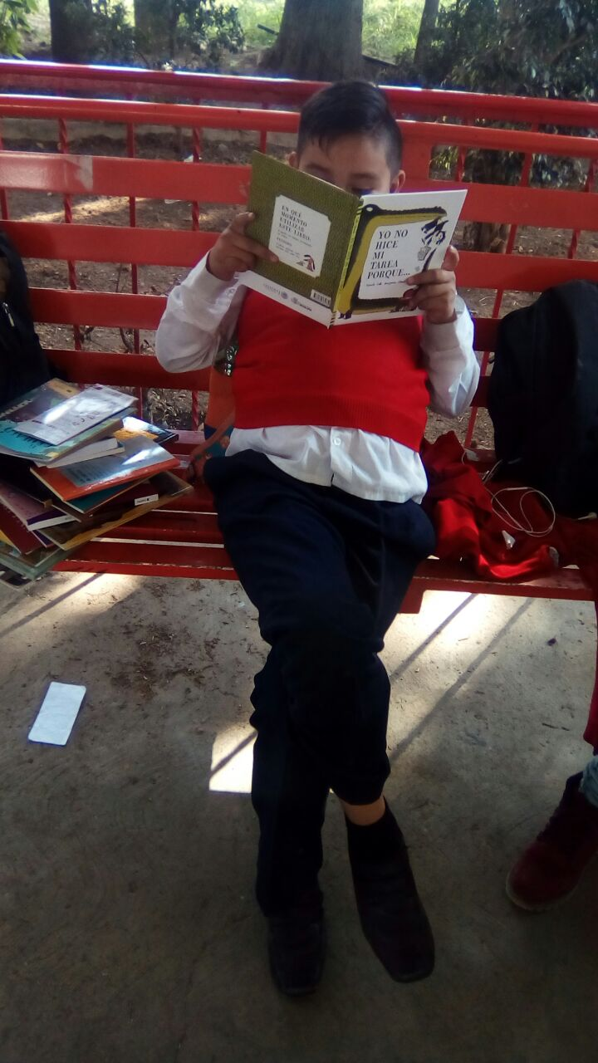
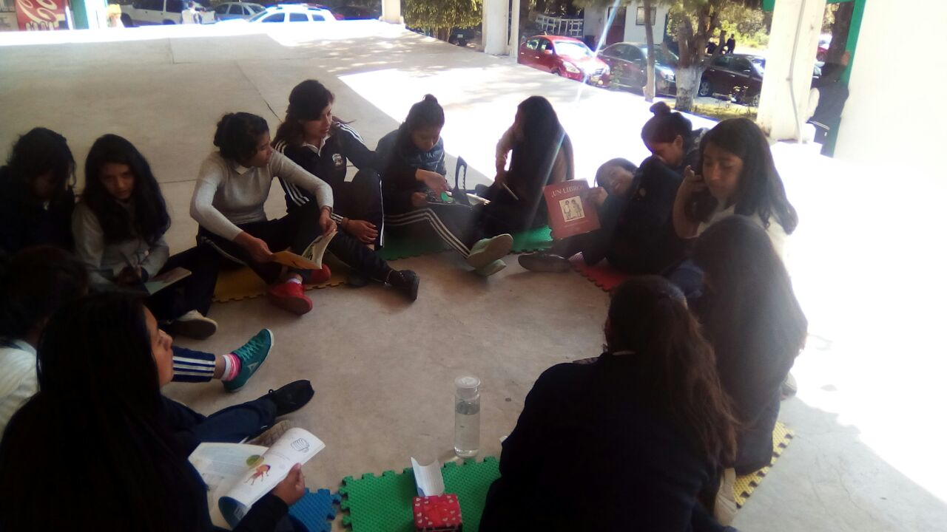

Bunko “San Gregorio Atlapulco”, Xochimilco, Ciudad de México.
In September of last year, an earthquake shook the city of Mexico, causing multiple damages to people and structures. Close to the city is the town of San Gregorio Atlapulco, in Xochimilco, which was also badly damaged by the seismic event. In this community, a private library owned by Professor Jaime Tirso Pérez Venancio, who has dedicated much of his life to the aforementioned library, collapsed among other buildings. The remarkable thing about this library is that since its creation it has given access to the members of the community to satisfy the need for information regarding the foundation of the town, customs and traditions, as well as recreation for the children of the town. All this without waiting or receiving a salary to support it. Due to the earthquake, the authorities and members of the community wanted to remove the rubble from the library, in which it is worth mentioning that the teacher and his wife were caught at the time of the event. Professor Jaime flatly refused to clear the rubble of the library because he knew the cultural richness that it contained both for him and for the community. It was so that in response to the call for help, IBBY Mexico contacted the teacher at first, to collaborate with volunteer work in the recovery of materials and managing financial support to solve the costs that the recovery of the collections required.
Thanks to this management we were able to access a fund enough to acquire bibliographic materials that enrich existing ones. This fund gave us the opportunity to acquire 200 titles of children's literature, containers for books, as well as training for 7 mediators of reading, who from this date will carry out voluntary work to promote literature with the children of the community. We hope that in the not too distant future the acquired acquis will be transferred to the Bunko (community library) that IBBY Mexico will install in the future headquarters of Professor Jaime's library, which will be called: “Centro Cultural Atlapulquense” (Atlapulquense Cultural Centre), which we must say, is going at uninterrupted steps in the recovery of the collections by a group of volunteers from the INH (National Institute of Anthropology).
Please, find beneath, the links to shared videos in the You Tube network before and after the library of San Gregorio Atlapulco.
Before: https://www.youtube.com/watch?v=HUxqiZ8DfSo
After: https://www.youtube.com/watch?v=KLeP-rtKL1A
I leave here photographs of the training to the mediators of the community who also give account of the delivery of the acquired acquis.

